1.

2.

3.

4.

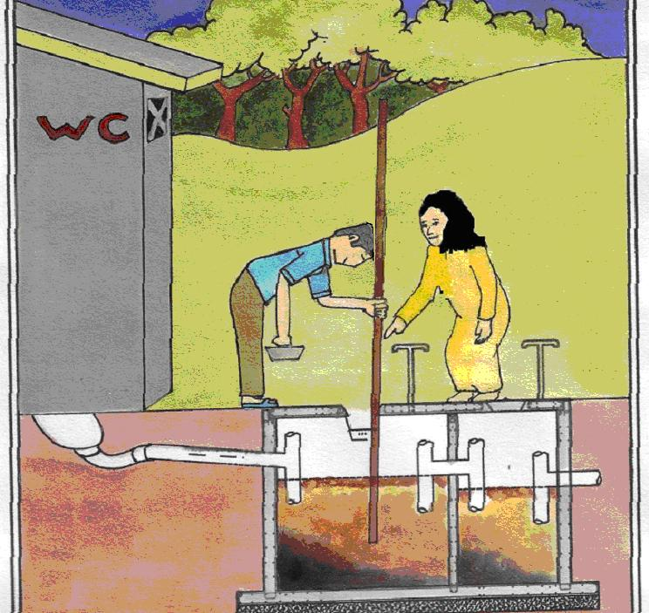
Poo-Pump Available At:

EVERY 2 YEARS THE SEPTIC TANK WILL BE FULL

WE CAN ALL USE THE POO-PUMP
IT’S EASY TO DO
IT’S NOT EXPENSIVE

THE HOLE FOR BURYING SLUDGE SHOULD BE AT LEAST 30 METERS FROM WATER SOURCES AND FAR AWAY FROM WHERE CHILDREN PLAY.

WELL

SLUDGE BURIAL SITE
30 m

30 m

RIVER

